Dynamic Malware Detection
Using
Network Analysis Traffic
User’s Manual

CHANGE LOG
USER’S MANUAL

Date | Version | Changes | Person
09/01/2014 | 1.0.0 | Initial draft | Aishwarya
09/08/2014 | 1.1.0 | First Interim presentation | Aishwarya
09/15/2014 | 1.2.0 | - Reference documents gathering  - Updating the Gantt Chart | Francis  Francis
09/22/2014 | 1.3.0 | - Identification of systems and installation  - Installation of Windows on VMware  - Installation of Kali Linux on VMware | Pragnya  Francis  Aishwarya
09/29/2014 | 1.4.0 | - Identification of web servers  - Identification of botnet to be used  - Identification of network traffic analysis tool | Aishwarya  Francis  Pragnya
10/06/2014 | 1.5.0 | - Complications in the botnet installation and research for other sources | Francis
10/13/2014 | 1.6.0 | - Remote desktop connection establishment  - Metasploit introduction | Francis  Francis

TABLE OF CONTENTS

CHANGE LOG ii
TABLE OF CONTENTS iii
OVERVIEW iv
ABSTRACT iv
GETTING STARTED 1
TOOLS/SOFTWARE USED 1
NETWORK ENVIRONMENT 2
INSTALLATION OF TOOLS/SOFTWARE 3
INSTALLING VMWARE PLAYER 3
INSTALLING WINDOWS XP 4
INSTALLING KALI LINUX 5
INSTALLING WIRESHARK 6
INSTALLING FTP SERVICE 7
INSTALLING APACHE WEB SERVER 11
INSTALLING SNORT 15
CONFIGURING SNORT 19
INSTALLING METASPLOIT 28
PROJECT IMPLEMENTATION 30
REFERENCES 31

OVERVIEW

Welcome to dynamic malware network, a detection mechanism is being developed by analyzing the network traffic for both the novice and the informed user. This document is to help guide the user through the process of our mechanism and the tools used.

ABSTRACT

Bots are one of the most sophisticated and popular types of cybercrime today. They allow hackers to take control of many computers at a time, and turn them into "zombie" computers, which operate as part of a powerful "botnet" to spread viruses, generate spam, and commit other types of online crime and fraud. In our project, we will provide a proof-of-concept botnet detection mechanism using a clustering analysis of network flows and we will work on a mechanism that is not dependent on specific botnet signatures or architectures.
First, a simple network is created with some simple network services running, this is to simulate a real network with lots of network activities. Then network activities are monitored and network traces are collected. This serves as a clean trace of network that has not been infected. Next, to simulate an infected network, we will use Metasploit, a tool used by penetration testers to find network vulnerabilities that can be exploited. Also, network activities are monitored and traces saved, to simulate an infected network. After this, both traces are analyzed to determine if an infection exists.

GETTING STARTED

TOOLS/SOFTWARE USED
VMWare Player- It is a development environment that allows system administrators to create and run virtual machines (VMs) directly on a computer system for various purposes like patch testing, software compatibility tests and a host of others.
Windows XP
Kali Linux- It is an advanced Penetration Testing and Security Auditing Linus distribution. It is mainly used by penetration testers and network security specialists primarily to determine how vulnerable a network is.
Apache Web server- it is generally recognized as the world’s most popular web (HTTP) server.
File Transfer Protocol (FTP) - It is used to transfer files between computers on a network.
Wireshark- it is a network packet analyzer. It captures network packets and displays those packets data as detailed as possible.
Snort- Snort is free and open source IDS (Intrusion detection system) and in some cases, IPS (Intrusion Prevention System).
Metasploit Framework- It is a tool for developing and executing exploit codes against a remote target machine.

NETWORK ENVIRONMENT
For the purpose of this project, we will be configuring a small and simple virtual network using VMWare. The network will consist of three systems.
System 1
This will have Windows XP installed. This will serve as the target system, since Metasploit targets a particular system or systems on a network. Also installed will be Apache HTTP web server and FTP server so this system will serve as both a web server and a FTP server.
System 2
This will also have Windows XP installed but it will act as a HTTP client and a FTP client. As this system is requesting for both HTTP and FTP services from system 1, HTTP and FTP traffic are generated which will be captured and saved by Wireshark.
System 3
This will have Kali Linux installed. This will serve as the attacker system. Kali Linux already has Metasploit Pre-installed, so it is from this system we will launch our attack on the target system (system 1).
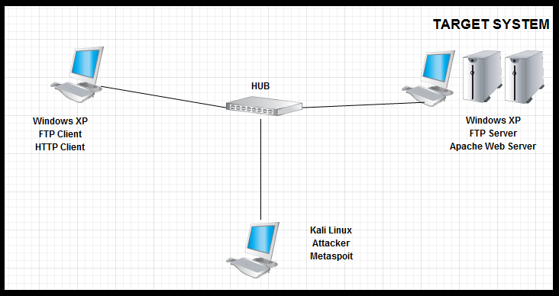
Simple Diagrammatic representation of the network

INSTALLATION OF TOOLS/SOFTWARE

INSTALLING VMWARE PLAYER
Navigate to https://my.vmware.com/web/vmware/downloads scroll down and download VMware player. Double click on it to commence installation.
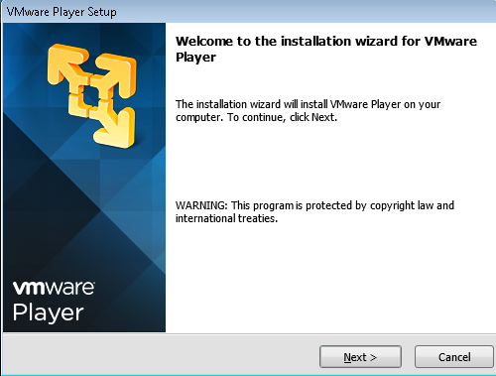
Accept the license agreement, click next five times, then click on continue to start installation. This will run for few minutes, then click on finish.
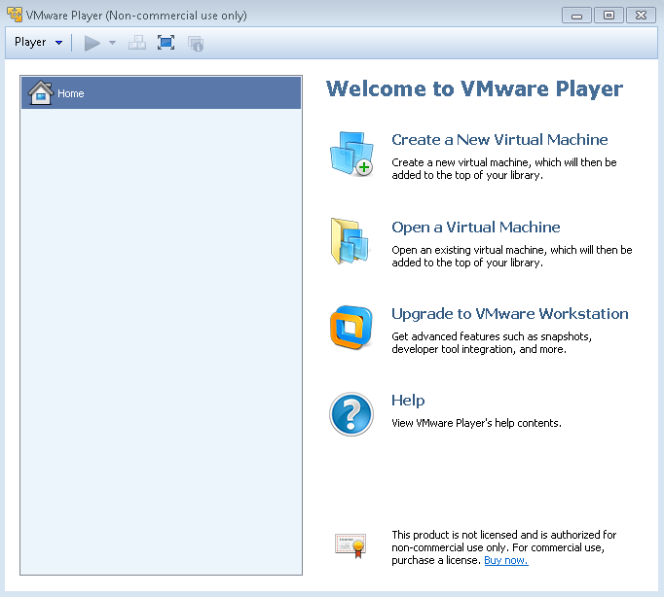

INSTALLING WINDOWS XP
For this installation, we will use a Windows XP installation CD. Click on player, file then new virtual machine. Select installer disc, since we have the installation CD in the DVD drive, then click next.
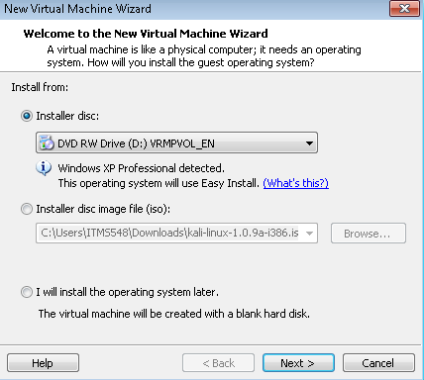

Then enter the product key, System name and system password if needed, then click next. Then enter a name for the virtual machine. Then click next. Allocate disk size and click next. Then an overview of all configurations are displayed, in case you need to change any settings. Then click on finish to start the installation. This will run for some minutes.
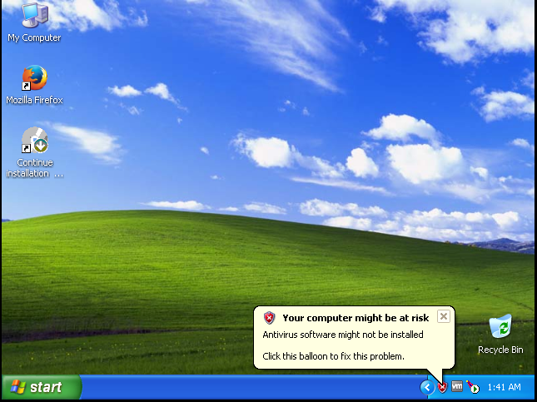

INSTALLING KALI LINUX
Navigate to https://www.kali.org/downloads/ and select the Kali Linux ISO image of choice and then download it. Open VMWare player, click on player, then file, and then new virtual machine. The new virtual machine wizard pops up. Select typical and click next. Choose the Kali Linux ISO that was previously downloaded, from the download location. :
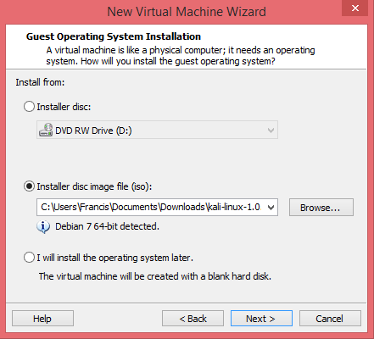
Assign a name to the virtual machine, allocate memory and disk space to the new virtual machine and click next. This displays an overview of all configurations of the new virtual machine to be created. Then click on finish to begin installation, follow all prompts and then the Kali Linux virtual machine should be created.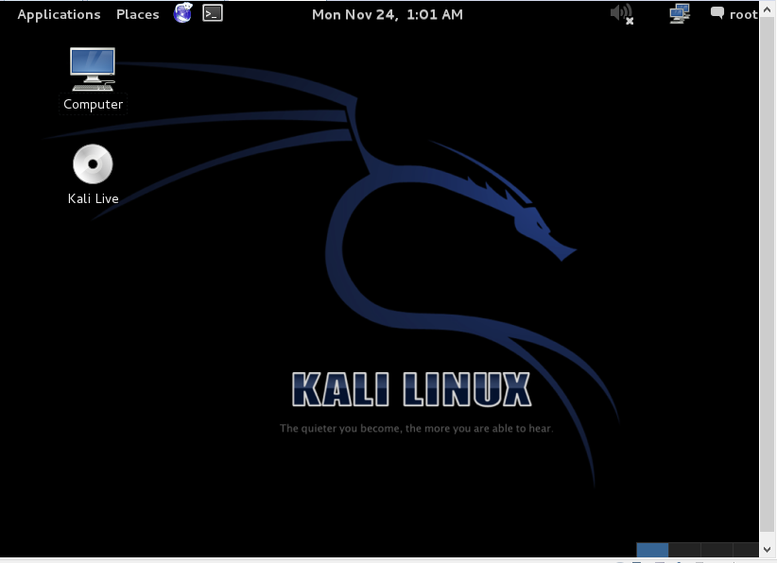

INSTALLING WIRESHARK
Navigate to https://www.wireshark.org/download.html then click on the version of Wireshark to be downloaded. Double click on it to commence installation.
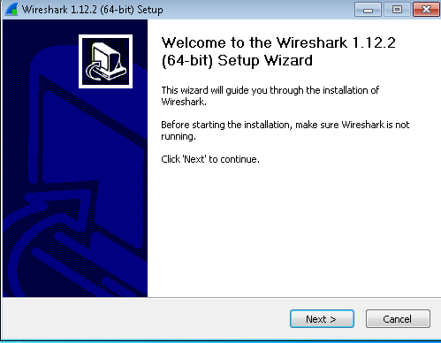
Click next, agree to the license, click next three times, make sure the install WinPcap checkbox is checked, then click install to start installation. This will run for few minutes, then click next to install WinPcap, agree to the license, then click install, then click finish. Click next, then click finish to complete Wireshark installation.
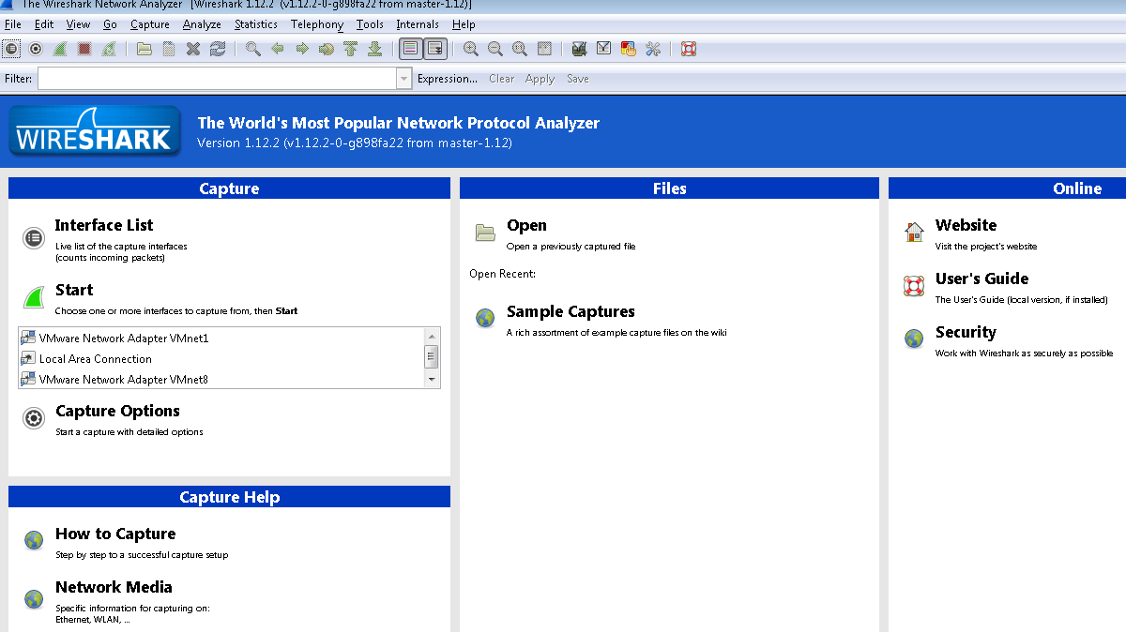

INSTALLING FTP SERVICE
For the purpose of this project, we are going to make use of the default FTP services in Windows XP. It is not installed by default so we will need to install it. NOTE: make sure you have the Windows XP installation CD as it is needed to complete the installation.
Click the start button, then control panel, then Add or remove programs. Then click on Add/Remove Windows Components.
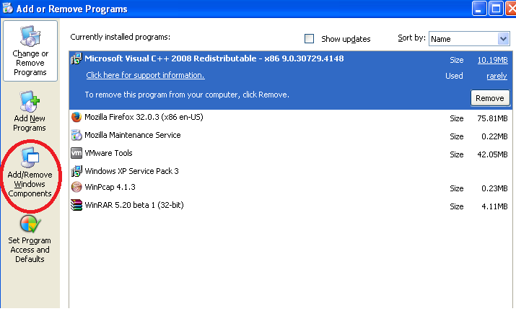

Then the Windows Components Wizard window will open. Scroll down, check the box next to Internet Information Services (IIS) and click on details.
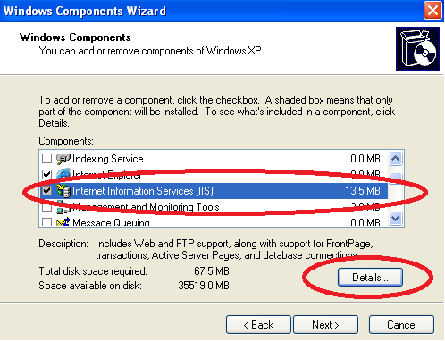

Then the Internet Information Services (IIS) window will open. Check the box next to File Transfer Protocol (FTP) service, click ok, and then click next.
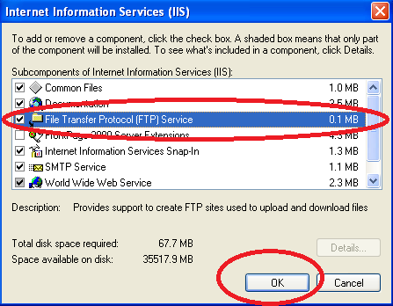

After a while, it is going to ask for the Windows XP installation CD. At this point, insert it into the DVD-ROM drive and the installation will continue automatically, if not, you can also click ok to resume installation.
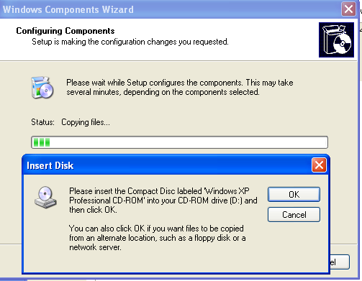
Then click finish when the installation is done.
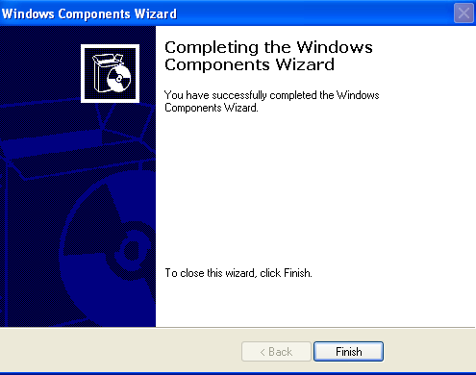
Now, the system will serve as a simple FTP server. Navigate to C:\Inetpub\ftproot folder and copy random files into it. Then on this same machine, open a web browser and type in the following ftp://localhost, this will open the folder where you have those random files. This is just to test out the new FTP server. So from any system on the network as this FTP server, open up a web browser and type ftp://ip_address_of_server and you will able to access public files on the FTP server.
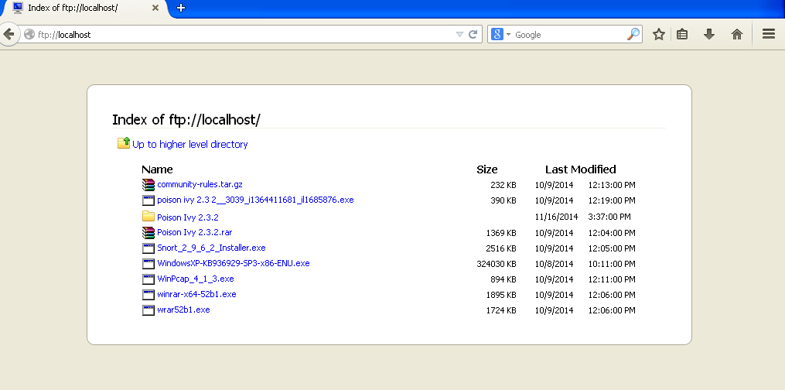

INSTALLING APACHE WEB SERVER
We will also install a web server, for this project, just for the purpose of generating http traffic when monitoring network activities using Wireshark. For this, we will be installing Apache web server.
First, navigate to http://httpd.apache.org/download.cgi to download apache. Scroll down to about half way, under Apache HTTP Server, click on Binaries.
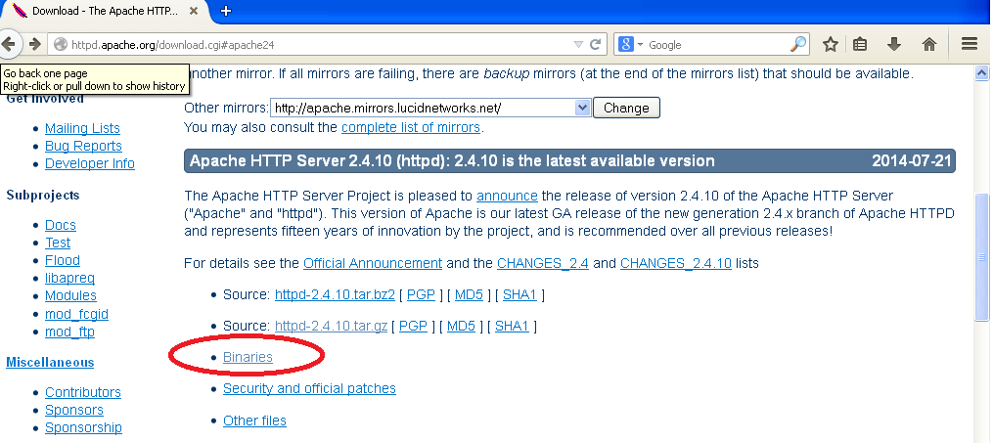

Then, click in win32, then click on the version you want, in this case, httpd-2.2.25-win32-x86-no_ssl.msi. This will download the executable Win32 Binary (Self extracting) file. Save the file, then double click on it to initiate installation.
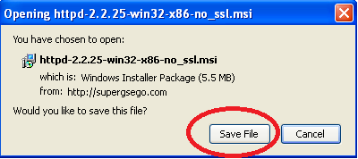

Then click next and follow the installation prompts.
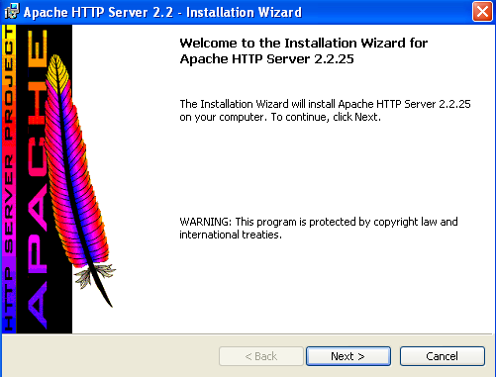

Accept the licensing terms and click next, then next again. Then you have to enter what your network domain is, server name and administrator’s email address. These were used for testing the server.
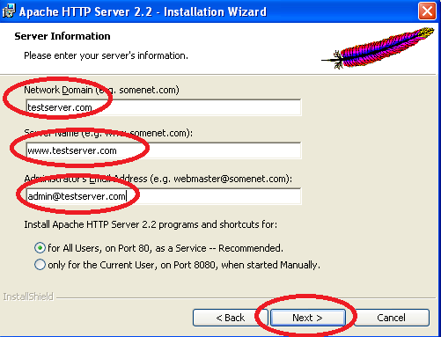
Then click next three times, then install to finish the installation. Then click on finish.
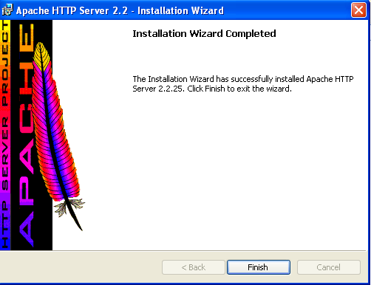
Then restart the system. After that, open a web browser and type localhost in the address bar. You should see the default page installed by the Apache installer. This shows that installation was successful. So from any other system on the same network as this web server, open a web browser and type in the ip address of the web server and you should also see the same page.
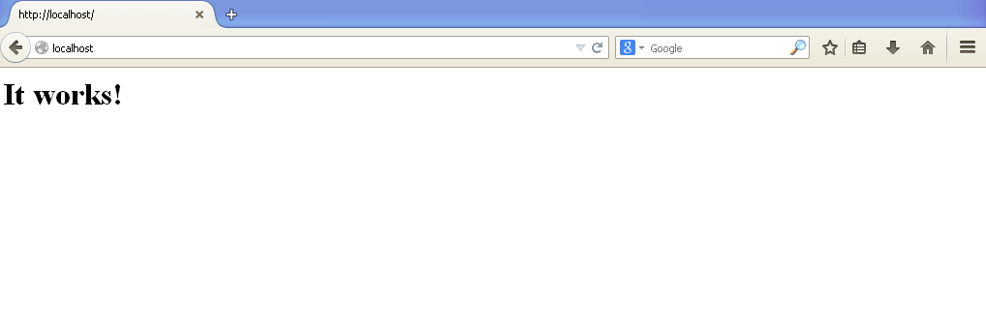

INSTALLING SNORT
Navigate to http://www.snort.org/downloads, and click on the .exe installer, since we are installing snort on a windows machine.
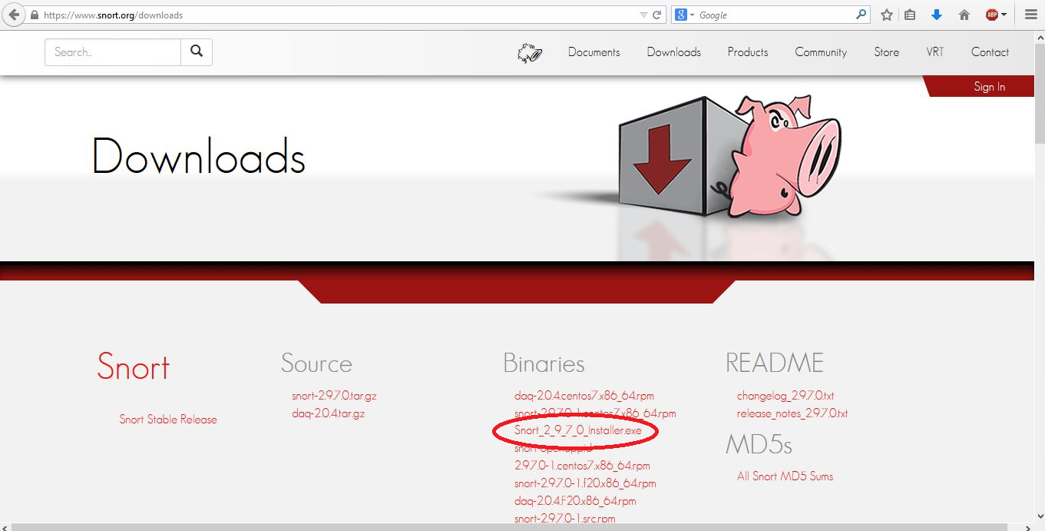

Then a dialog box would appear asking to save the snort installer to be downloaded.

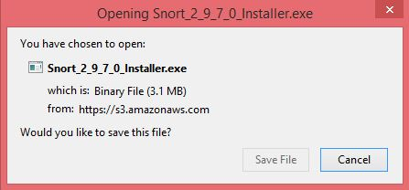

After downloading the file, navigate to the folder where the file is saved and double click on the program, and follow all prompts to commence the installation of snort.
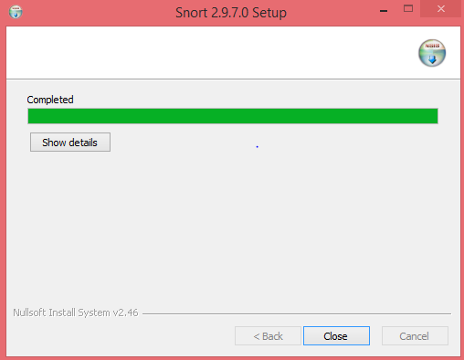

As an optional installation, WinPcap is also required for snort to function. So if it is not installed, you can navigate to http://www.winpcap.org to download the latest version of WinPcap, in this case, as at the writing of this manual, WinPcap 4.1.1.
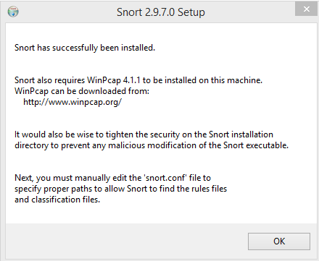
After installation of snort, next we need to download the snort rules associated with the version of snort we downloaded, in this case, Snort 2.9.7.0. Still on the snort download page, scroll down to the section that says rules and download the snort rules needed. You may need to sign in to snort or create a snort account in order to download the rules.
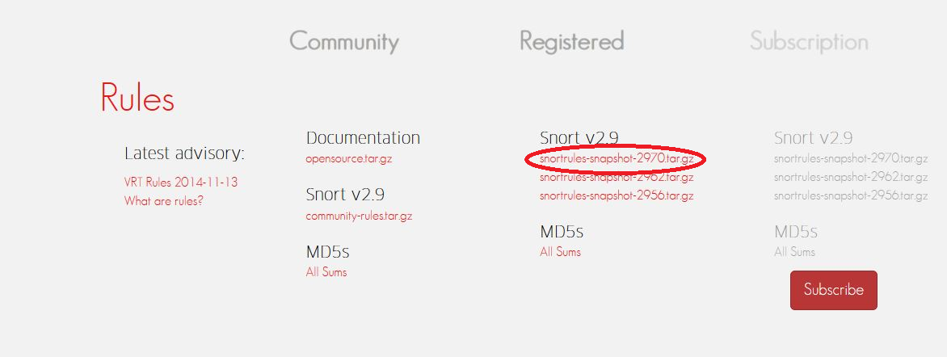

After clicking on the snort rules, a dialog box will appear, asking to save the rules file. Also, make sure you have WinRAR, or WinZIP or any other software that can extract the rules file, since it is in a compressed format after download.
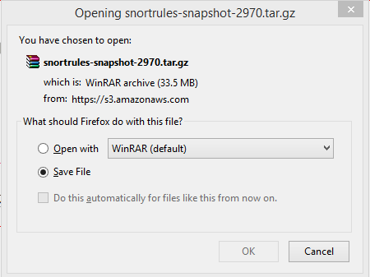

After download, extract the rules file to a folder. Then copy all contents of the extracted file to the location where snort is installed, in this case C:\Snort. A prompt will ask to replace files in the C:\Snort folder, so accept to overwrite or replace existing files and folders.
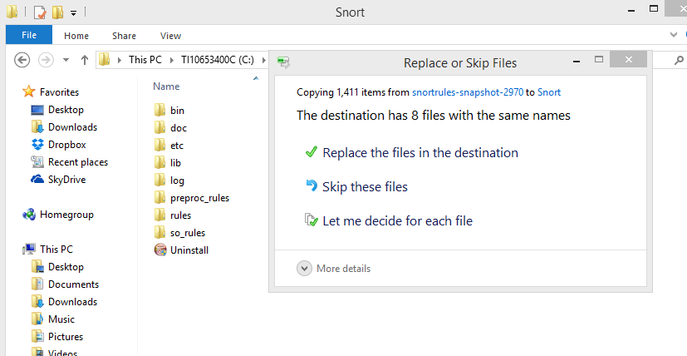

CONFIGURING SNORT
Now that snort has been installed, there are some basic configuration settings that needs to be set before snort can actually be used. First, navigate to the snort configuration file, C:\Snort\etc\snort.conf. Right click on the file and open it with any word processor like wordpad, notepad or Microsoft word.
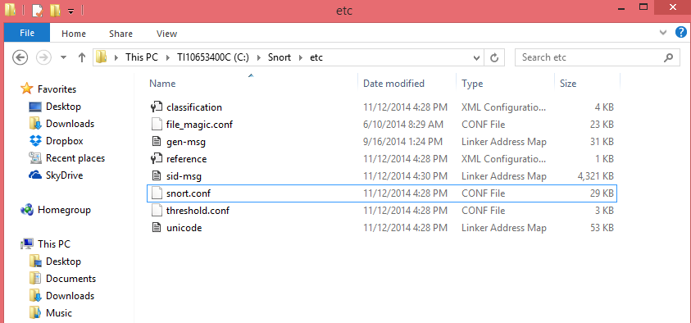

When the configuration file has opened, make the following changes; Searh the file for the following lines;
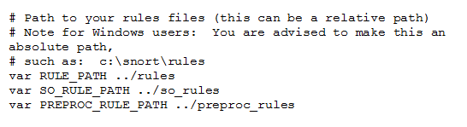
And change it to the following. This allows snort to locate the location of all rules file needed.
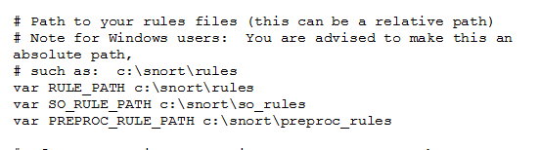
After this, also search for the following lines;
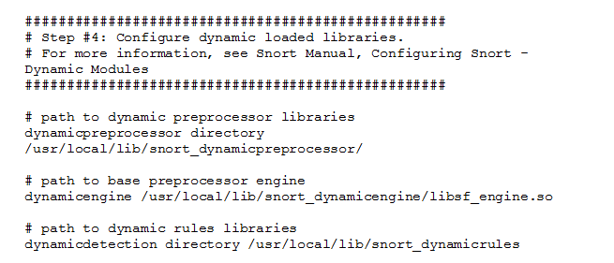

And replace it with the following
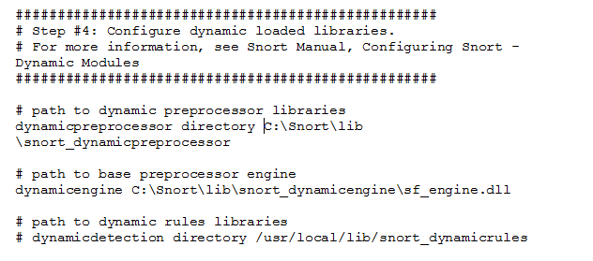

Since we will not be using dynamic rules, we can comment out that line by adding a hash/pound sign (#).
Next, also search for the following lines;
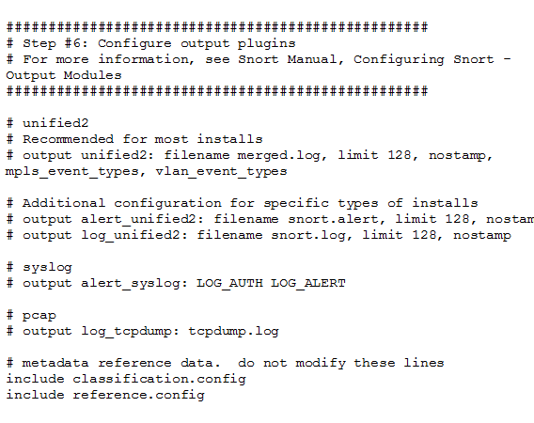
And replace it with the following. This is just to indicate the output file that all alerts will be logged in by default, though alerts can be logged in other ways. This is needed for snort to pass the configuration test. Also, navigate to C:\Snort\log\ folder ,open notepad and save the empty file within this folder with the name alert.ids.
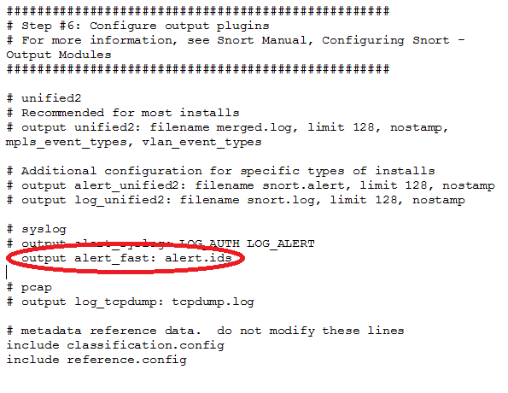
Search for the following lines;
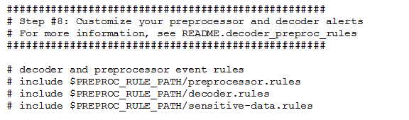
Uncomment the last three lines. These file paths are needed for the detection, display and logging of alerts in either the alert.ids file or to be displayed on the console.
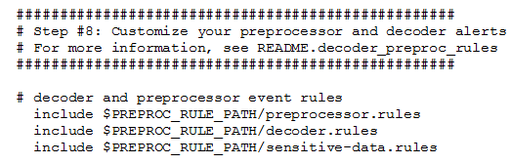

Lastly, search for the following line,
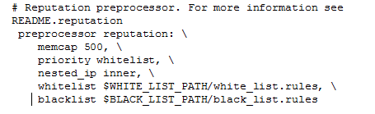
And replace it with the following, since we will not be needing this block of settings for the scope of this project, so comment out all lines.
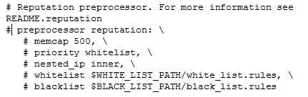

Now that we are done with the snort.conf file, we can try and test our configuration to see if it passes or to see if there are errors. Since snort by default based is entirely based in the command line interface, open the command prompt window by holding the windows key and pressing the ‘R’ key. This will open the Run Window, then type cmd, and press enter.
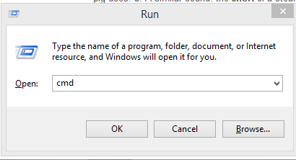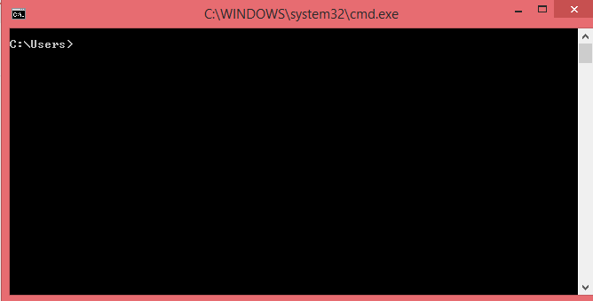

Now, we can run snort to display the list of available snort commands, flags and the necessary syntax for executing any command. Typing ‘snort - - h’ will display the help window. After the execution of the command, if it says that snort is not a recognized commend, then you will have to add the file path for the snort executable in the environment variables of the computer properties.
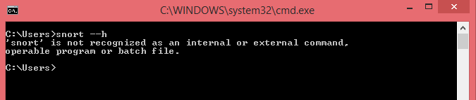

To do this, right click on My Computer, then select properties, then click on Advanced system settings, then click on Environment Variables, under system variables, scroll down, select Path and click on edit. In the variable value field, click inside it, then add the file path to the sort executable file in there, in this case ;C:\Snort\bin then click ok, then ok again, then ok for the third time... Note the semicolon that precedes the file path.
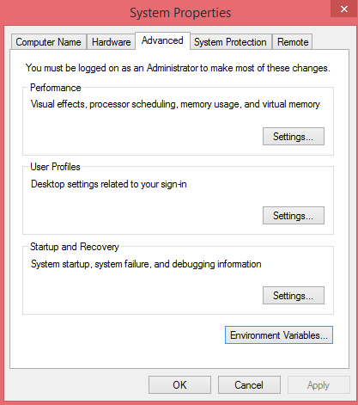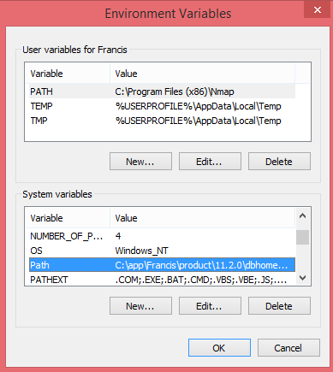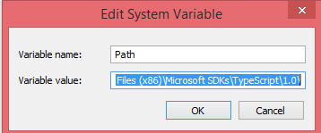
Now running the snort - -h command to display the help menu should run without errors. 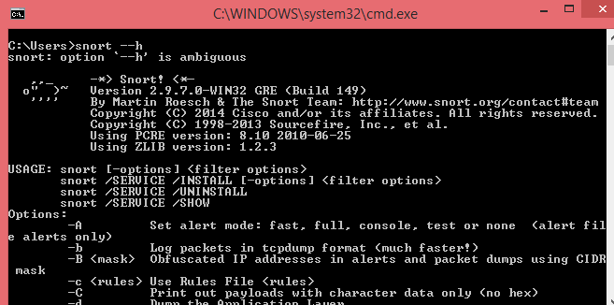

Now, run the command, snort –W, this displays all active interfaces. You will need to identify the interface number snort will listen from, as it is needed to test snort configurations and for using snort in IDS mode as well as packet logging and sniffer modes.
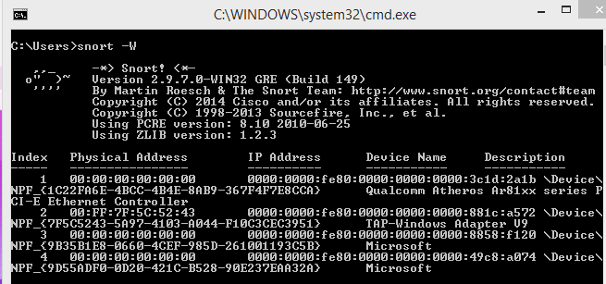

Now to test snort configuration, type the following;
snort -c c:\snort\etc\snort.conf -l c:\snort\log –i4 -T
Option | Meaning
-c | Use Rules File (snort.conf)
-l | Log to directory
-v | Be verbose
-i | Listen on interface(as shown I the previous figure)
-T | Test and report on the current Snort configuration

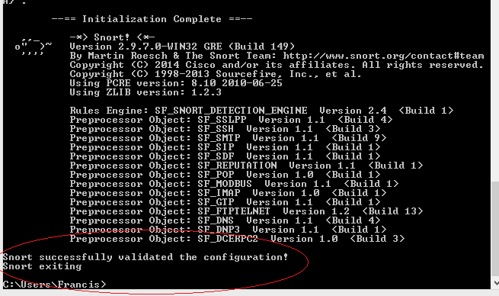
If all settings are configured correctly, snort should pass the configuration test. If it indicates that there were errors, follow the configuration steps one at a time over again so as to correctly configure snort.

INSTALLING METASPLOIT
Since we are using Kali Linux, Metasploit is already installed by default. To open Metasploit, click on Applications, then Kali Linux, then Exploitation Tools, then Metasploit, then Metasploit framework.
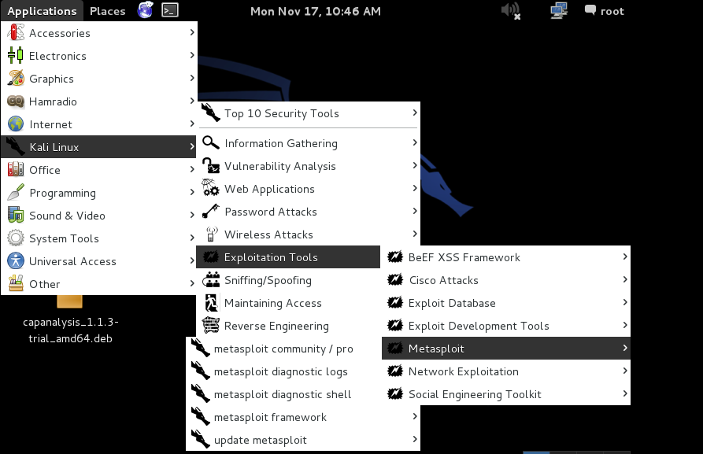
Then after some moments, the metasploit framework window will be launched.
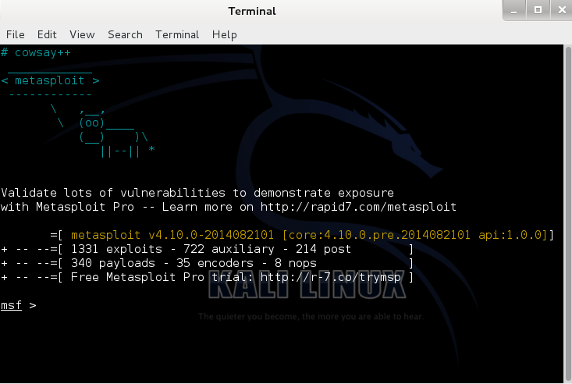

PROJECT IMPLEMENTATION

REFERENCES

http://compnetworking.about.com/cs/webservers/g/bldef_apache.htm
http://docs.kali.org/introduction/what-is-kali-linux
http://en.wikipedia.org/wiki/Metasploit_Project
http://openmaniak.com/snort.php
http://searchvmware.techtarget.com/definition/VMware-Workstation
https://kb.iu.edu/d/aerg
https://www.wireshark.org/docs/wsug_html_chunked/ChapterIntroduction.html#ChIntroWhatIs

